*Supplemental Material*

***Table 1***

|  |  |  |  |  |  |  |
| --- | --- | --- | --- | --- | --- | --- |
| **Name** | **Web** | **Desktop** | **Free and Open Source?** | **Draws Haplotypes?** | **Last Updated** | **Notes** |
| *Cranefoot* | Would not load, unverifiable | Windows binaries available  Source provided for manual compilation upon other platforms (Linux, Mac) | ☑ | ☒ | 2014 | Config files do not work and pedigree creation is text-intensive. |
| *Cryllic3* | ☒ | Windows | ☑ | ☑ | 2011 | Haplotype rendering untested. Paid application. |
| *Kinship* | ☒ | R-package, no user interface | ☑ | ☒ | Unknown |  |
| *MadelinePDE* | ☒ | Command line | ☑ | ☒ | Unknown |  |
| *PED6* | ☒ | Windows and Mac binaries available. | ☒ | ☒ | 2013 |  |
| *PEDhunter* | ☒ | Linux | ☑ | ☒ | Unknown | Tool used by NCBI in conjunction with their browser. Standalone, but requires their data sets. |
| *PedGraph* | ☒ | Windows | ☒ | ☒ | Unknown |  |
| *Pedigree/Draw* | ☑ | ☒ | ☒ | ☒ | 2014 |  |
| *Family Genome Browser* | ☑ | Java-based | ☑ | ☑ | 2015 |  |
| *HaploPainter* | ☒ | Perl-based (requires Cairo and TKinter) | ☑ | ☑ | 2005 |  |

*A comparison of the 10 main pedigree and haplotype rendering programs considered in the scope of this paper. Note that only Cranefoot, Family Genome Browser, and HaploPainter perform both pedigrees and haplotype rendering.*

***Figure S1***

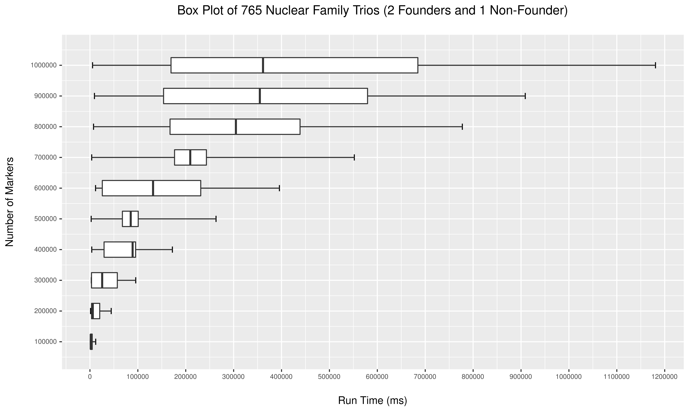

*Trios generated for large numbers of markers (100,000 to 1,000,000) with each number of markers run 20 times with the same input parameters. Haplotype resolution was included in the run time together with rendering time in low-graphics mode. The browser (Chromium) was automatically refreshed before each run. The run time variance increases with the number of markers, but with lower number of markers remained relatively consistent.*

***Figure S2***

*Scatter plot showing HaploForge run time versus the number of individuals in the pedigree for pedigrees with up to 100 individuals.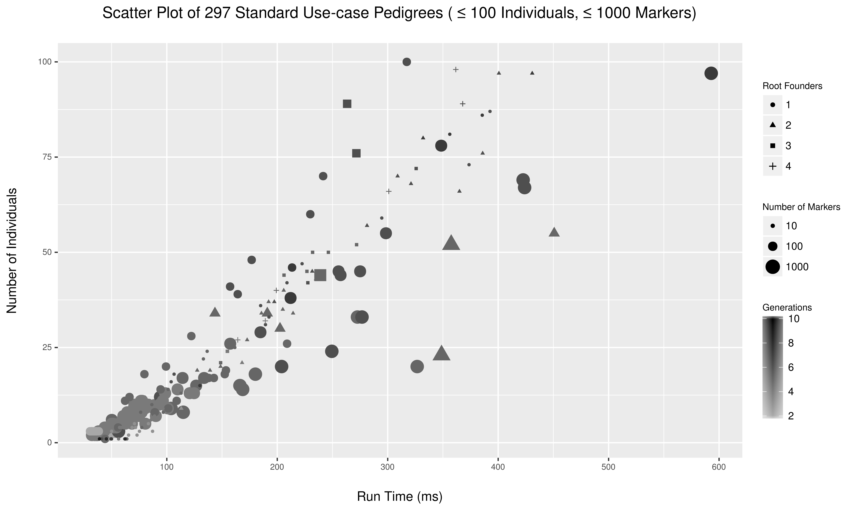 Run time increases linearly with the number of individuals, irrespective of the number of generations and markers. HaploForge rendering and haplotype resolution is effectively instantaneous for < 100 individuals.*

***Figure S3***

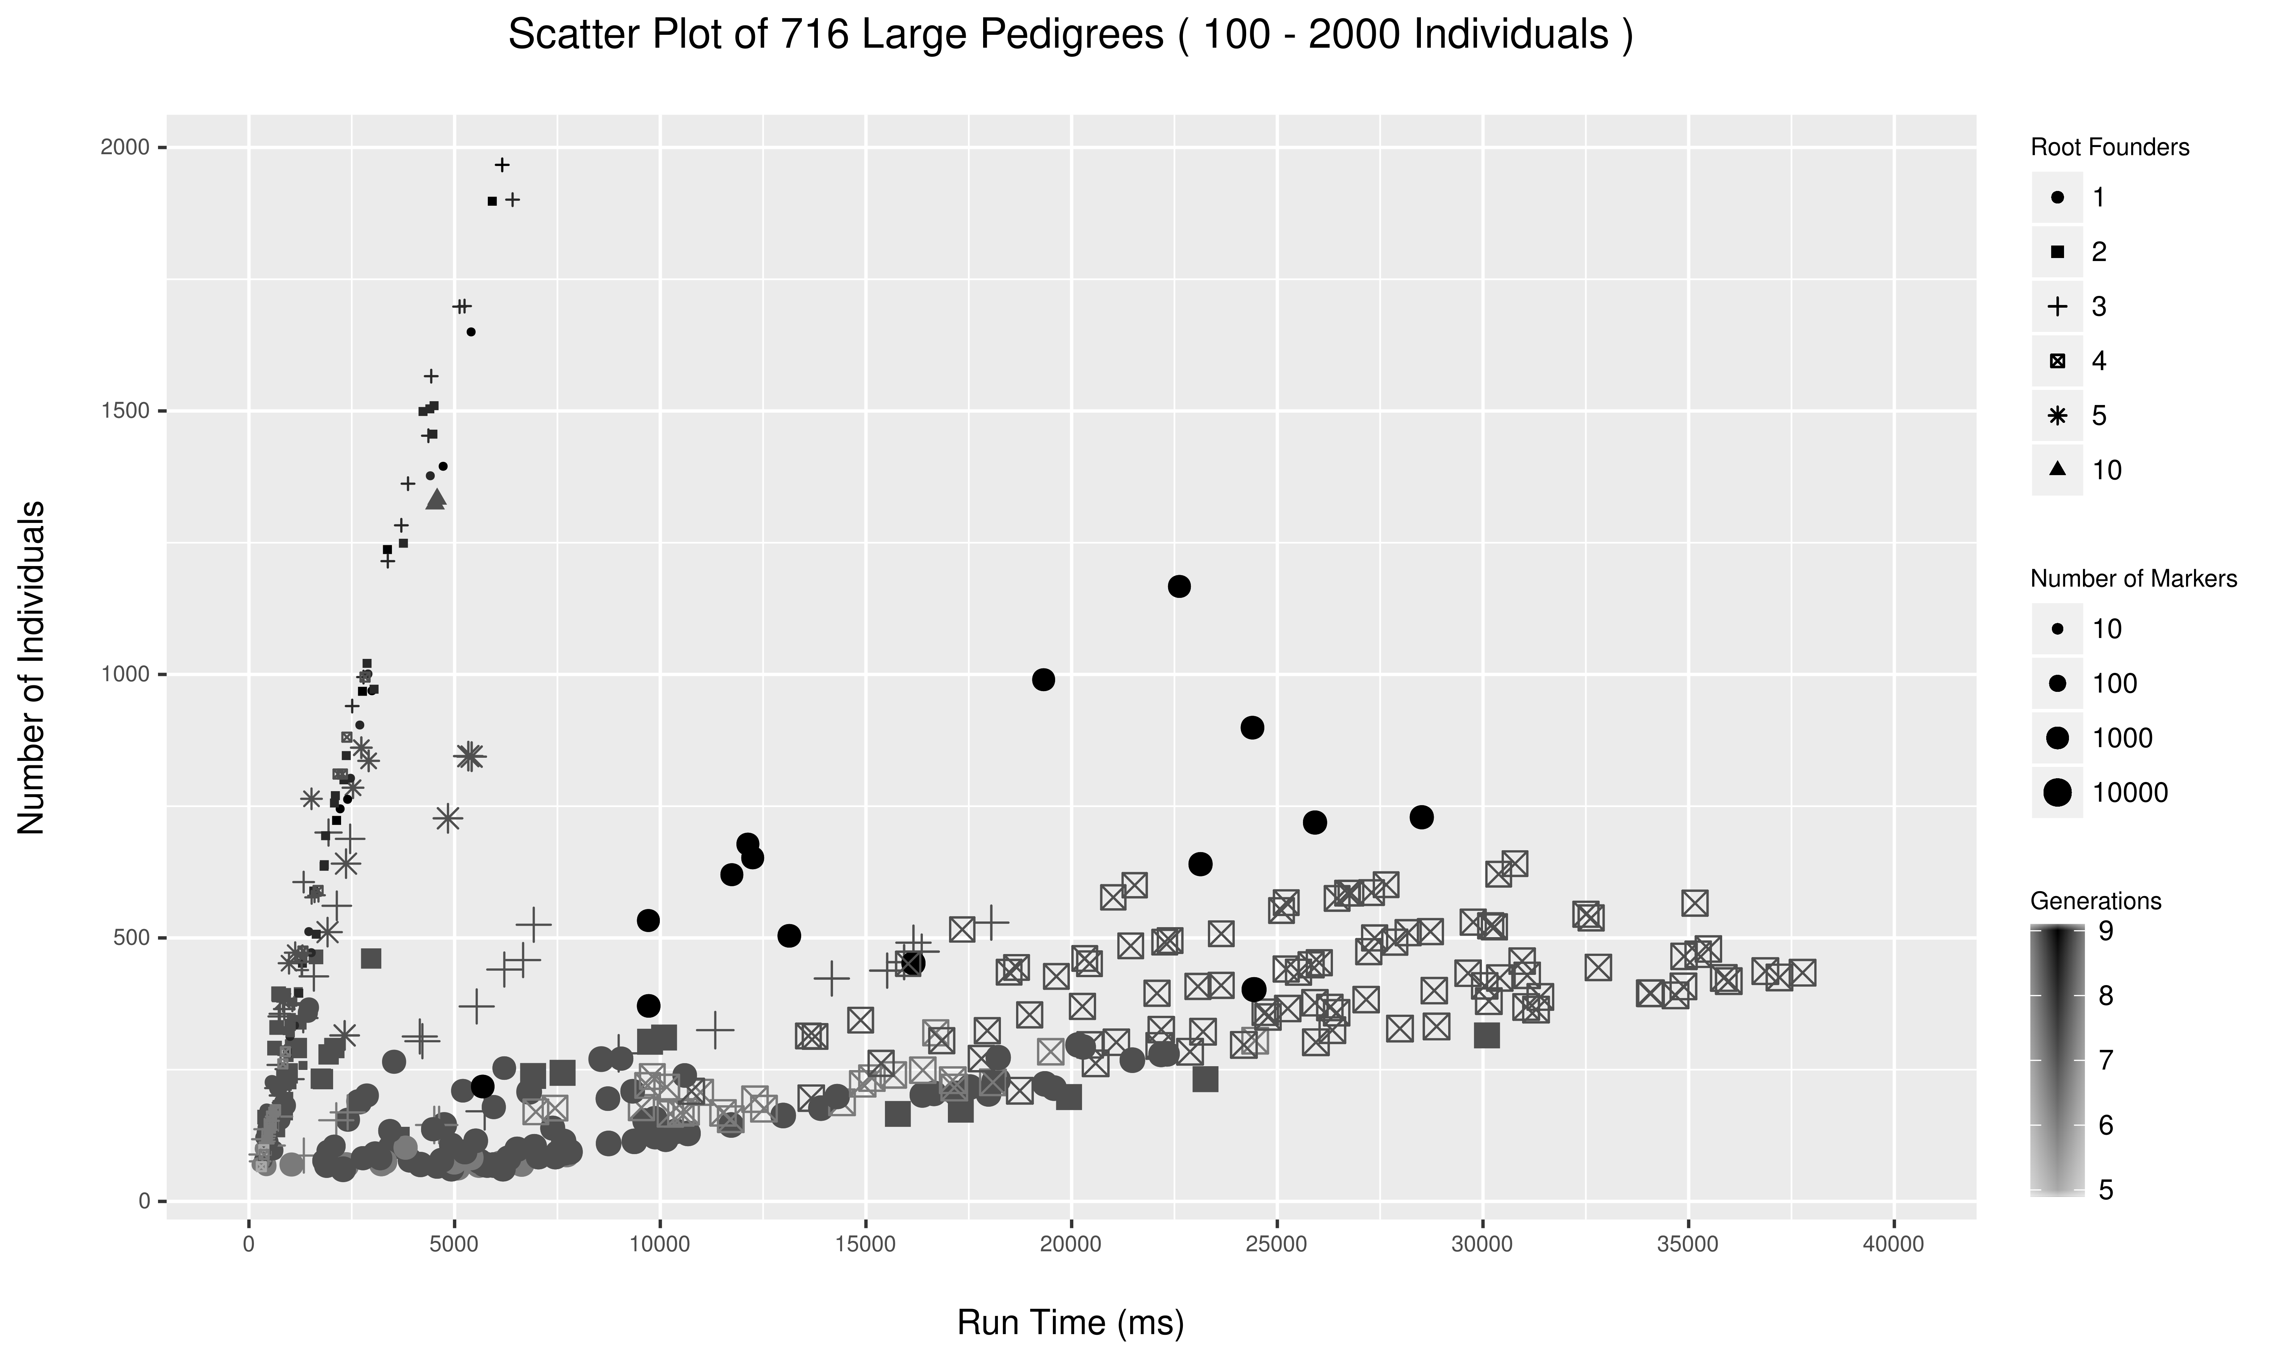*Scatter plot showing HaploForge run time versus the number of individuals in the pedigree for large pedigrees (100-2000 individuals). Run time increases with the number of individuals, but stratified by the number of markers and root-founders.*

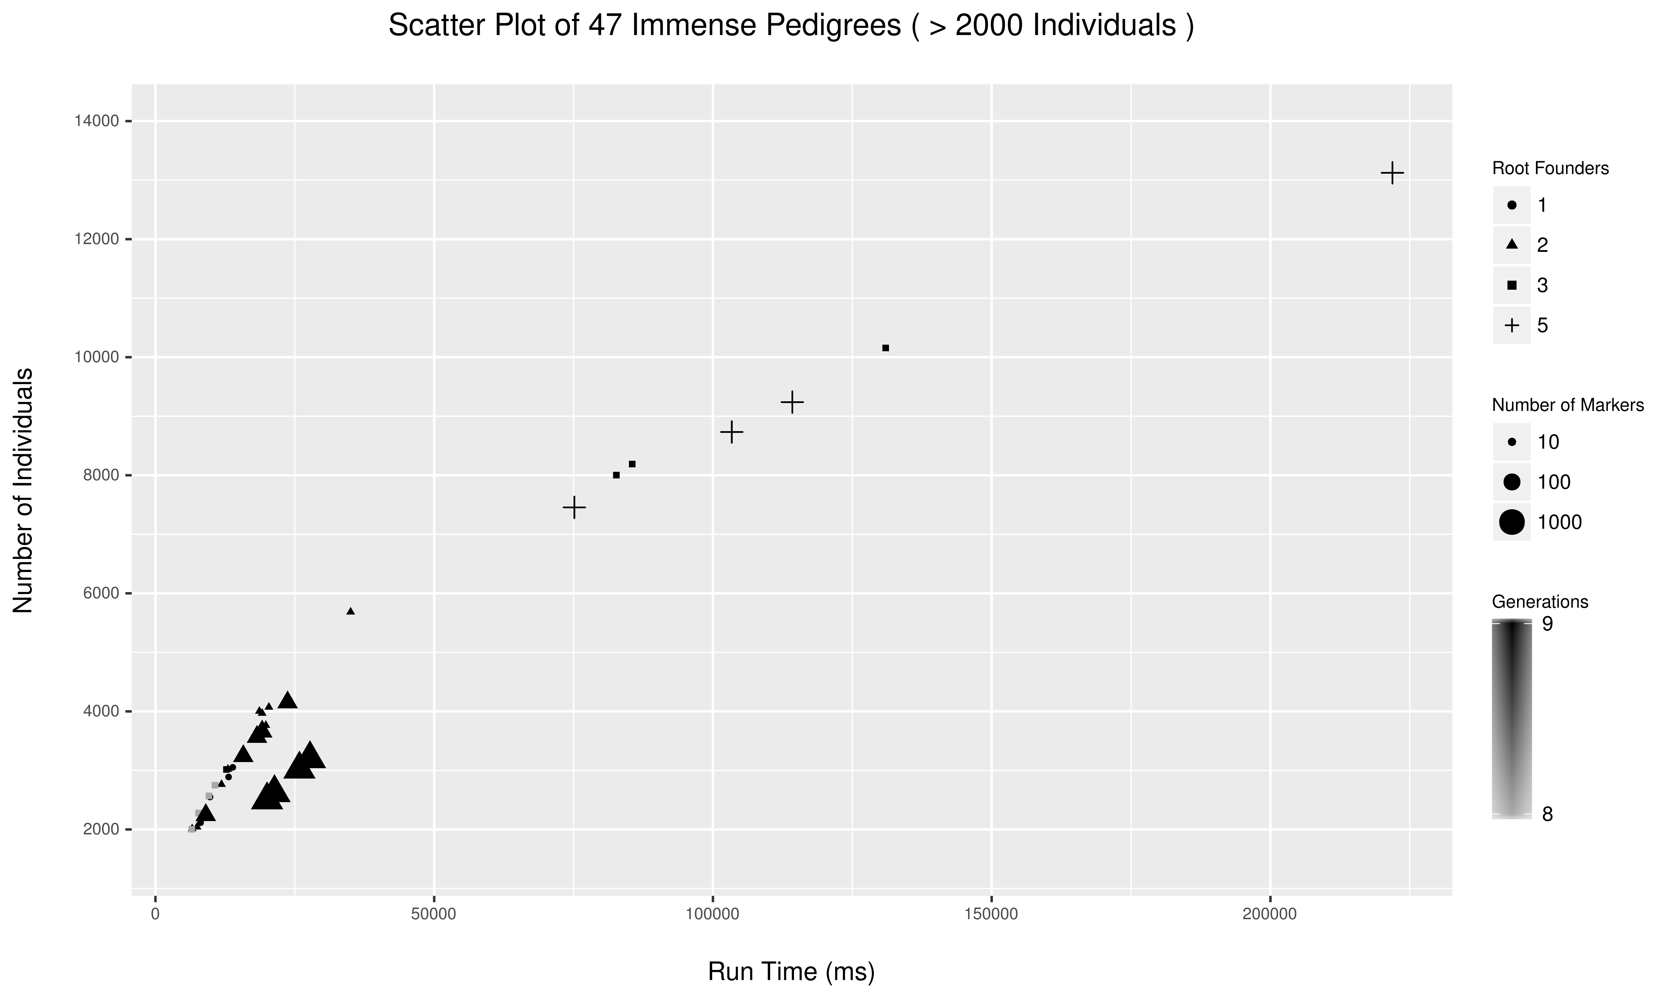***Figure S4***

*Scatter plot showing HaploForge run time versus the number of individuals in the pedigree for massive pedigrees (> 2000 individuals). Run time is linear in the number of individuals, but fewer experiments were run due to the time required.*